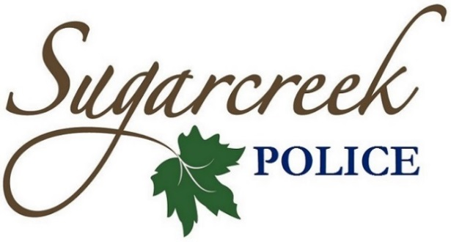
Michael A. Brown
Chief of Police

November Police Blotter

November 1, 2023
- Business and house checks
- Community policing
- Crash report on Ferry Road

November 2, 2023
- Theft arrest on Wilmington Pike
- Domestic violence on Center Point Drive
- Crash report on Wilmington Pike
- Traffic stops

November 3, 2023
- Theft report on Shannon Court
- Domestic dispute on Wilmington Pike
- Request of an officer on Feedwire Road
- Theft report on Rachel Court

November 4, 2023
- Theft arrest on Wilmington Pike
- Request of an officer on Surrey Trail

November 5, 2023
- Nothing to Report

November 6, 2023
- Juvenile complaint on Upper Bellbrook Road
- Request of an officer on Clyo Road
- Suspicious vehicle on Wilmington Pike

November 7, 2023
- Nothing to Report

November 8, 2023
- Crash report on Middle Run Road
- Crash report on Clyo Road
- Traffic stops

November 9, 2023
- Harassment report on Persimmon Ridge Place
- Theft arrest on Wilmington Pike
- An animal complaint on Wilmington Pike
- 911 Hang up on Statehouse Court

November 10, 2023
- Burglary reported on Oak Creek Drive
- Crash report on Centerville Road
- Crash report on Swigart Road
- Welfare check on Centerville Road
- Theft report on Clyo Road

November 11, 2023
- Crash report on Shellbark Drive
- An animal complaint on Upper Bellbrook Road
- Welfare check on Wilmington-Dayton Road
- Domestic violence reported on Oak Creek Drive
- Juvenile complaint on Wilmington Pike

November 12, 2023
- Nothing to Report

November 13, 2023
- Community policing
- Welfare check on Clyo Road
- An animal complaint on Stewart Road
- Request of an officer on Wilmington Pike

November 14, 2023
- Business and house checks
- Community policing
- Welfare check on Surrey Trail

November 15, 2023
- Traffic stops
- Crash report on Ferry Road
- Crash report on Wilmington Pike

November 16, 2023
- Nothing to Report

November 17, 2023
- Theft arrest on Wilmington Pike
- Fraud report on Winding Brook Way
- Request of an officer on Coffeat Drive
- Criminal damaging reported on Feedwire Road

November 18, 2023
- Theft report on Brookdale Lane
- Community policing
- Theft report on Wilmington Pike

November 19, 2023
- Nothing to Report

November 20, 2023
- Community policing
- Suspicious person on Bayberry Cove Drive
- Welfare check on River Bluff Drive
- Theft report on Feedwire Road

November 21, 2023
- Theft arrest on Wilmington Pike
- Welfare check on Centerville Road
- Domestic violence reported on Bayberry Cove Drive

November 22, 2023
- Nothing to Report

November 23, 2023
- Juvenile complaint on Surrey Trail
- Community policing

November 24, 2023
- Welfare check on Clyo Road
- Theft arrest on Wilmington Pike
- Noise complaint on Surrey Trail

November 25, 2023
- Nothing to Report

November 26, 2023
- Community policing
- Theft arrest on Wilmington Pike
- Business checks

November 27, 2023
- Nothing to Report

November 28, 2023
- Suspicious person on Feedwire Road
- Disturbance on Wilmington Pike
- Theft arrest on Wilmington Pike

November 29, 2023
- Business checks
- Community policing
- Theft report on Waynesville Road

November 30, 2023
- Suspicious vehicle on Wilmington Pike
- Traffic stops

